Hi Students,

Let’s try to make the best of things the next few weeks. For the next few weeks, I need you to occasionally work on this packet when you get some downtime. You are not required to complete this during your time away from school, but it will be due by the end of the year. Hopefully, this will keep you on pace despite the time away from school. Do not procrastinate and wait until the last week of school. Work on it at home, drop by when you get back during homeroom hours, and use my course resources to help you complete the packet.

This packet will be available in class on Monday, and on my website (www.nickaugustine.org) for your convenience. You may also contact me by email (naugustine@nbcusd.org) if you have any questions or concerns. My goal is not to overwhelm you with materials, but to reinforce the curriculum during your downtime. Be there for your families and support your community safely during your time away from school, but also take a few minutes each day to review some course content and plan ahead for your finals. Finally, I will leave you with a nerdy cartoon that I really enjoy.
Take Care,
Mr. A

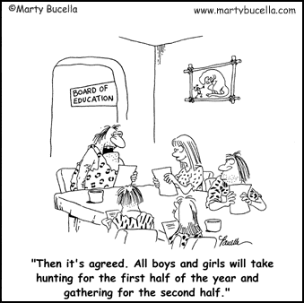

Name _____________________________________________________________ Period ____
WORLD HISTORY DETECTIVE
GREAT CIVILIZATIONS OF MESOAMERICA & SOUTH AMERICA
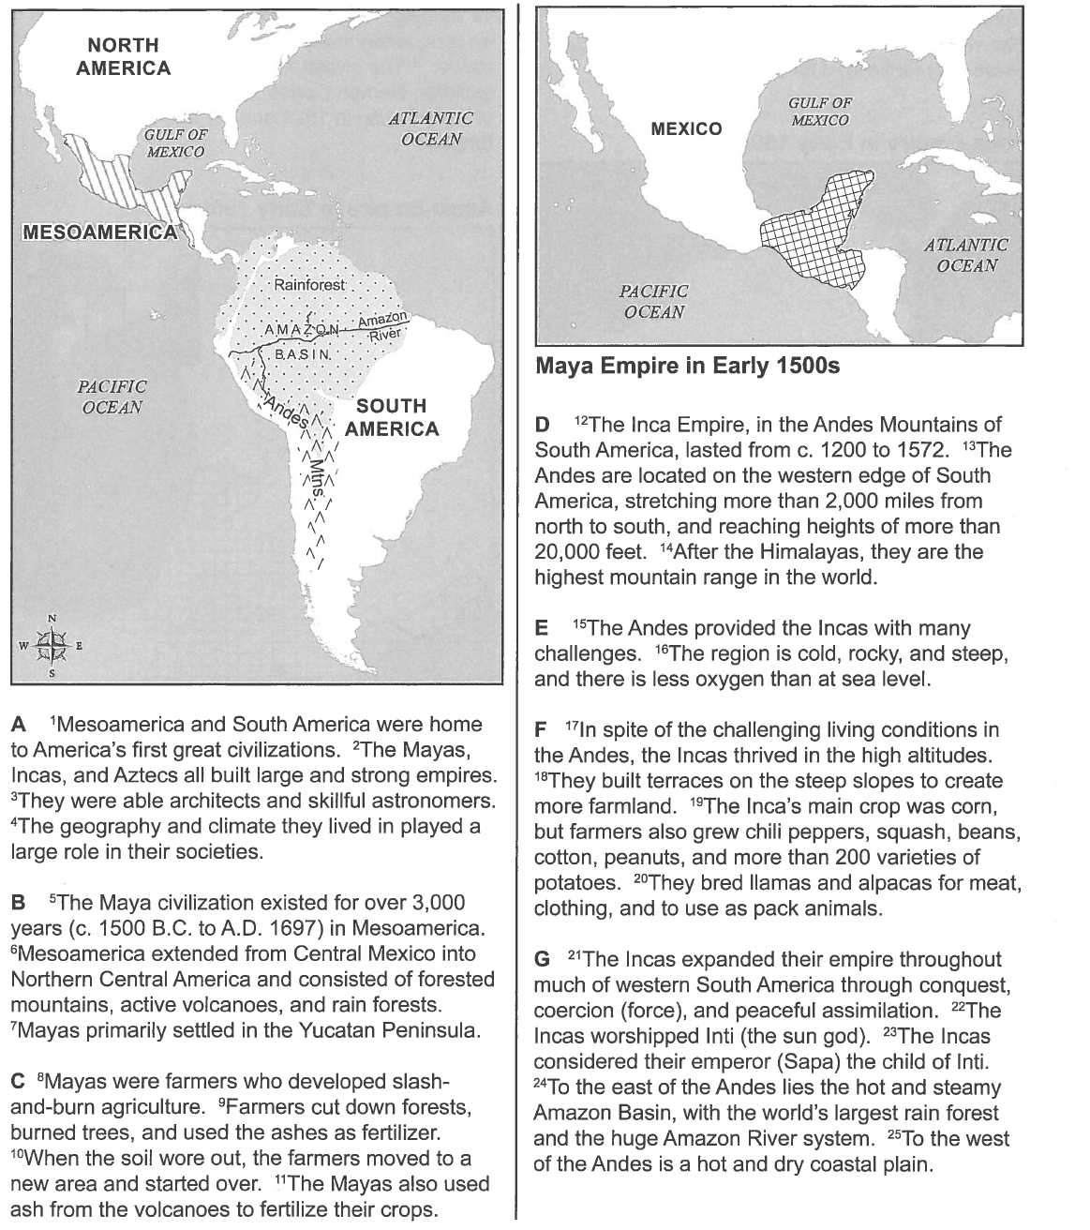
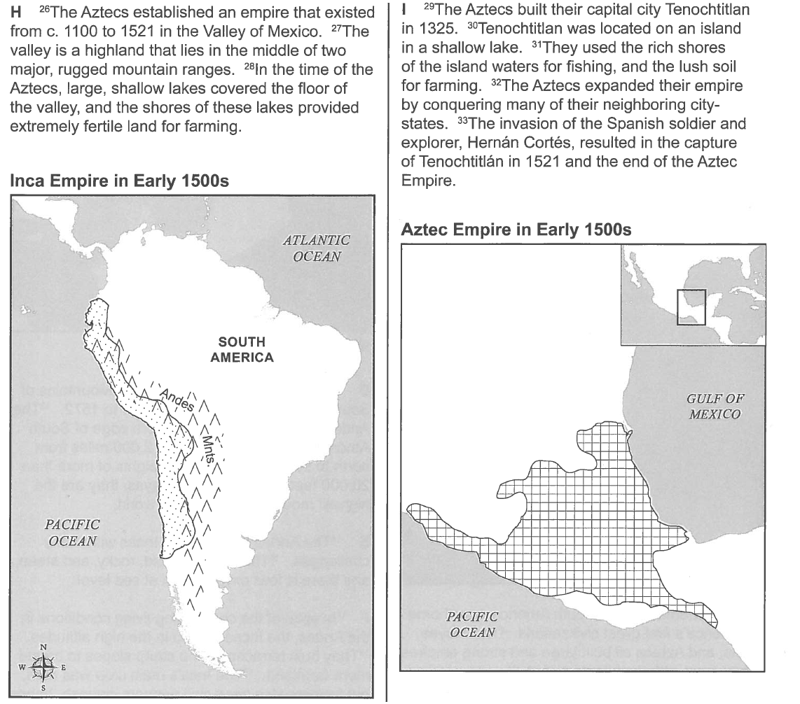

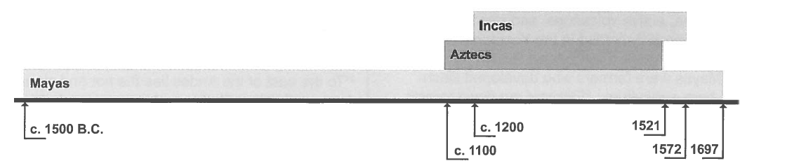

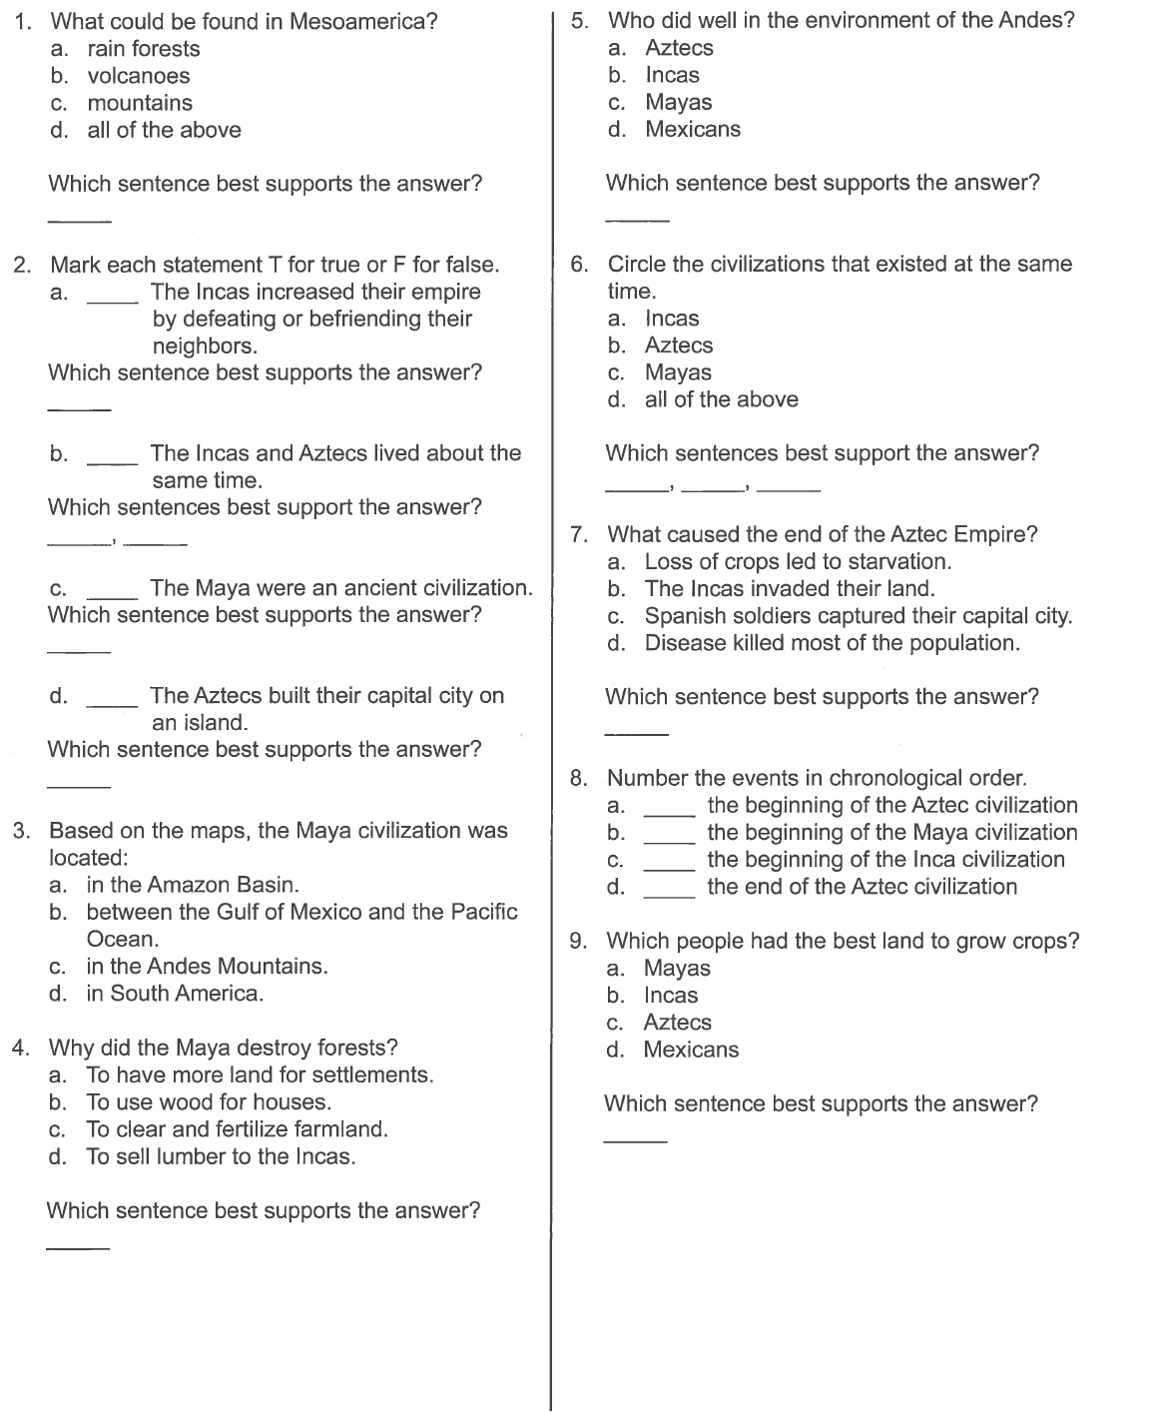

Enter these notes into your notebooks.

Europeans Explore the Americas
- 1493 - Pope Alexander VI established a line of demarcation.
- The Treaty of Tordesillas resolved a dispute between Spain and Portugal over the right to claim new lands. It did two things:
  - This gave Portugal the right to control the route around Africa to India
  - Spain claimed the new lands of the Americas, except for what is now Brazil.
- 1520 - Ferdinand Magellan, discovered the strait at the southernmost tip of South America.
  - His crew became the first known people to circumnavigate, or sail around, the globe.
Spanish Rule in the Americas
- Two Kingdoms: New Spain and Peru; both ruled by a viceroy (an official who rules in place of a king
  - cabildos (councils made up of wealthy landowners) governed towns
- Mercantilism: belief that a country should gain as much gold as possible by exporting more goods than they imported.
  - supply raw materials to parent country
  - serve as a market for manufactured goods
The Search for Labor
- Encomienda system - settlers’ right to demand taxes or labor from the people living on the land. Results:
  - genocide of many Native American groups
  - haciendas - large plantations owned by Spanish settlers
A Slave System
- Portuguese exchanged weapons for gold, salt, and slaves
  - myth: Africans were better suited to slavery than Native Americans
The Columbian Exchange
- The Columbian Exchange was a series of interchanges that permanently changed the world’s ecosystems and changed nearly every culture around the world.
  - Native Americans and Europeans learned new farming methods and were introduced to new crops and foods
  - Europeans also brought diseases that killed millions of Native Americans

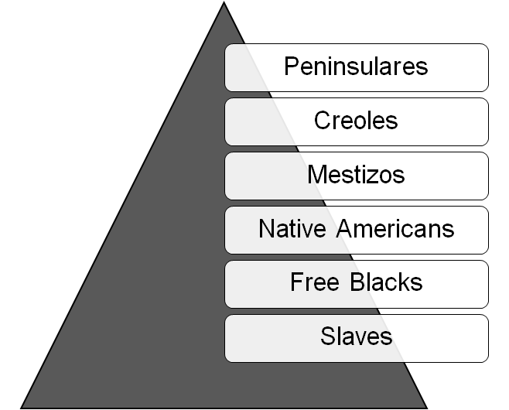
A Rigid Class System
- Peninsulares - highest class; officials sent by Spain to rule the colonies
  - controlled economy and government in the colonies
- Creoles - American-born descendants of Spanish settlers
- Mestizos - People of mixed Indian and European descent

The Roman Catholic Church
- Missionaries set up churches, built missions, and tried to protect Native Americans
- The Church spread Christianity among the African slaves
- The Church became the largest property owner in Latin America

Revolution!
***Independence movements in the 18th and 19th centuries were led by leaders such as Miguel Hidalgo, Toussaint L’Ouverture, Simon Bolivar, Jose de San Martin, and Jose Morelos. Revolutions were sparked in Haiti, Central and South America, and Mexico.

Gaining Independence in Latin America
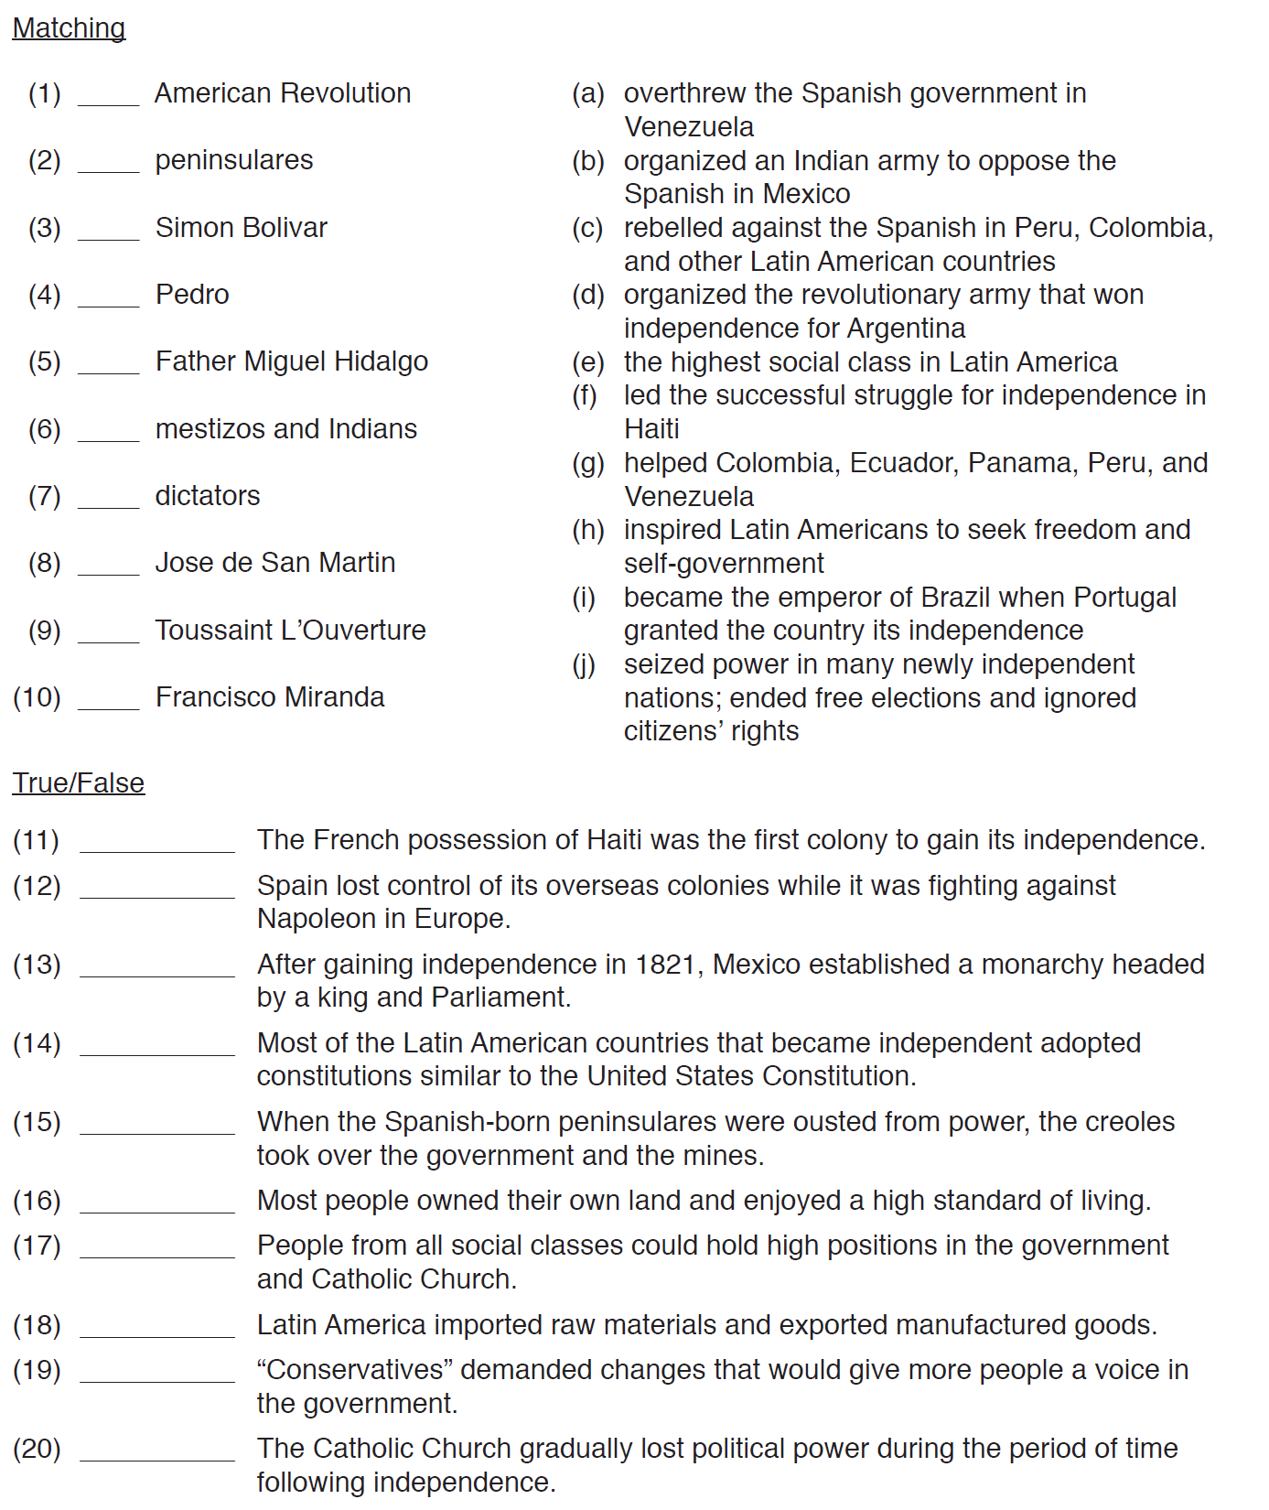

Identify Nations of Latin America - South America

1. | 9.
2. | 10.
3. | 11.
4. | 12.
5. | 13.
6. | 14.
7. | 15.
8.

