Russia Notes Worksheet
- Which group below had control over Russia during the Middle Ages?
- Chinese b) French c) Mongols d) Ottoman Turks

- What did Genghis Khan and the Khans that followed demand of the Russians?
- Tribute
- Loyalty
- Resources
- All the above

- Which city was the center of Byzantine influence and early Russian culture?
- Moscow b) St. Petersburg c) Kiev d) Galich

- Where was the Grand Prince located?
- Moscow b) St. Petersburg c) Kiev d) Galich

- What was used to translate the Christian Bible to the Russian population?
- Hieroglyphics b) Cyrillic alphabet c) Latin d) English

- Who was the first to unite the Russian princes against the Mongols?
- Charlemagne b) Ivan the Terrible c) Pope Urban d) Ivan III

- Why was it difficult to access the vast resources of the Russian frontier?
- No waterway access c) Difficult and dangerous terrain
- Very limited workforce d) The princes were too poor

- What served as a model for later Russian rulers?
- Kingdoms of Western Europe c) The Japanese samurai
- The Mongol Khans d) The Pope

- What was the faith of the Russian population before the fall of the tsars?
- Islam b) Roman Catholic c) Judaism d) Eastern Orthodox

- What is the Russian translation of tsar?
- King b) Supreme Ruler c) Caesar d) Holy One

- Who attacked the “boyars”?
- Genghis Khan b) Ivan III c) Ivan the Terrible d) Caesar

- Short Answer: What is the problem with the triangle section of the map below?
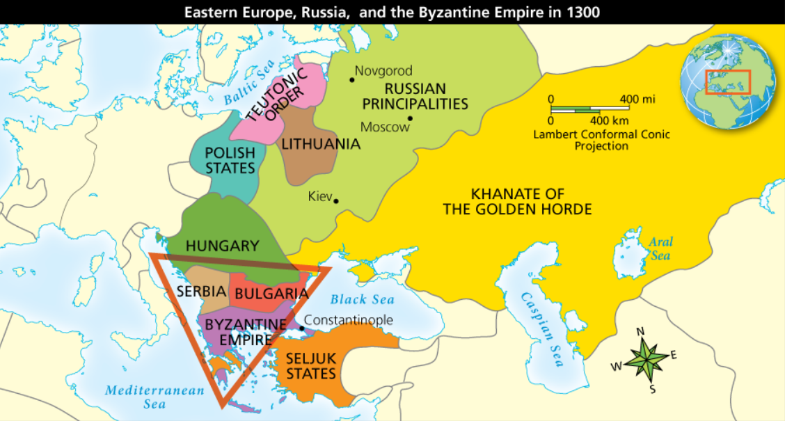
______________________________________________________________________________________________________________________________________________________________________________________________________________________________________________________________________________________________________________________________________________________________________________________________________

- Short Answer: Use the map to explain the Viking influence on Russian culture.



