Economics Final Project- How does starting a business work and what do you have to do to begin?
Students will demonstrate the competencies for Economics based on completion of the following project. All portfolios must be submitted by 12/15 for review. Students who choose not to complete the project will take the Economics Final Exam.

- Research the process of starting and owning a small business.
  - Choosing a name for your business
  - What goods/services your business will offer
  - The process of finding a location for your business (Lease or buy? Zoning? Parking?)
  - The process of getting funding for your business (Loans? Investors?)
  - Contracting with suppliers
  - Hiring employees
  - Making your business sustainable/profitable going forward

- As part of your research, conduct an interview with someone experienced in starting up and owning a small business.
  - Write at least 10 questions for the interview beforehand.
  - Collect the historical data of the company
  - Identify notable pitfalls and successes of the company
  - Establish the cause of the success and or failures of the business

- Documentation of data/time
  - Research (where you keep research details and sources).
  - Keep a learning log (keeping track of time spent on the project).
  - Complete a final reflection at the end of your log.

- Write a business proposal portfolio for potential investors describing your business.
  - Include the ideas listed above. Be informative and detailed about how you will start and run your business (you’re trying to convince people to buy in to your concept…literally!).
  - Plan, create, and publicly present a detailed presentation which showcases what you learned to faculty, administrators, and community business members. ($10,000 per teacher, $20,000 per administrator, and $40,000 per community member)
  - Include information from your portfolio. Submit this information by 12/15 for review.

Area of Focus | Meets all requirements. Terrific plan. | Meets most requirements. Adequate submission. | Meets some requirements. A little more work needed. | Does not adequately meet requirements. Back to the drawing board.
Name recognition and viability.
Identify items sold or services offered. Factor in materials, equipment, labor, and insurance.
Location (visible, rent/lease/buy, hours of business, zoning)
Funding (gifts, loans w/ detailed pay structure, and investment options.
Contract supplies and req. materials, maintenance, safety equipment, etc.)
Salaries & Hourly Rates, Employee benefits, schedules, Duties, Specific Skills
Goal Development: Years 1-5

Task Log
Date & TIME Event
12/2 11:12-12:02 | Brainstorming ideas for businesses. Review of expectations with teacher.

Notes regarding Log entries:________________________________________________________________________________________________________________________________________________________________________________________________________________________________________________________________________________________________________________________________________________________________________________________________________________________________________________________________________________________________________________________
Task Log
Date & Time Event

Notes regarding Log entries:______________________________________________________________________________________________________________________________________________________________________________________________________________________________________________________________________________________________________________________________________________

Investing options:
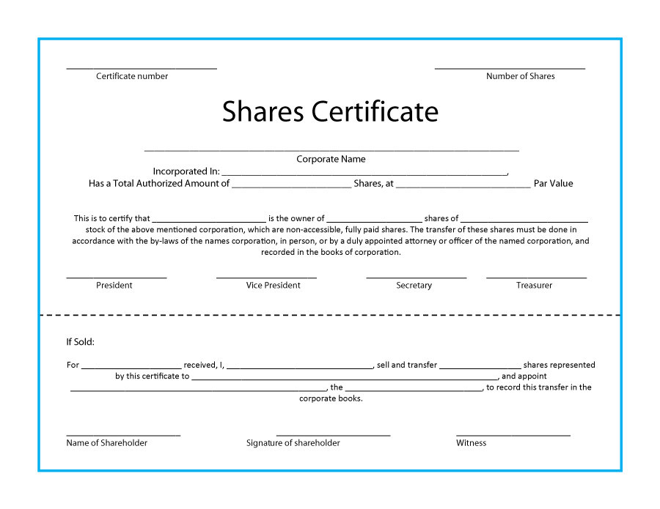
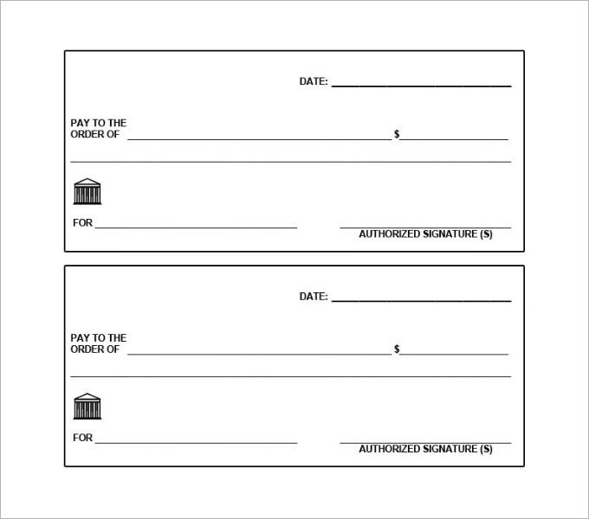

Sources of Financing for Small Business

https://www.debt.org/small-business/sources-financing/
Approximately 80 percent of the estimated 27.5 million U.S. small businesses – defined as those with fewer than 500 employees – use some form of credit to help finance their operations. That financing includes bank loans, credit cards and lines of credit. Before the financial meltdown of 2007 and 2008, it was easy for many businesses that relied on their credit lines – and repaid them regularly and on time – to renew or extend those credit lines. All it took was a quick call to their lenders.
A small business line of credit allows a firm to borrow money up to a pre-specified amount. These lines of credit can provide a business with cash reserves to meet day-to-day expenses and do not require collateral as long as the business is deemed credit-worthy by a lender. Lenders make money on the credit lines though fees and interest that accrue on any balance. And although banks could always lower credit limits or call in loans if economic conditions compelled them to do so, this only happened occasionally – usually when a business was delinquent in its payments or had other problems that increased its credit risk. As the country works through a sluggish recovery, small businesses must access whatever forms of money and credit are available to them. Here are some alternative sources and methods of financing to consider.

1. Community Banks

2. Credit Unions

3. Finance Companies

4. Unsecured Lines of Credit
Small-business owners may be able to secure lines of credit even if their businesses are currently losing money, as long as their personal credit scores are high – generally above 700. Several companies arrange business credit lines for low-risk borrowers through a network of financial institutions, but the price is high – an additional 10 percent of the line’s value on top of the bank’s 5 to 9 percent cut.

5. Cash
For small-business owners who cannot get credit, whose credit lines have been reduced or revoked, or who just don’t want the hassle or high interest rates attached to other forms of financing, a business savings account can provide a ready source of cash that can be tapped into when necessary. This is essentially an emergency fund to be used only to offset temporary cash-flow problems and not for capital improvements or other purchases. Such a fund can help keep a small business out of debt and forgo the need to borrow.

